### **Summer Flip Flop Shoe Box**

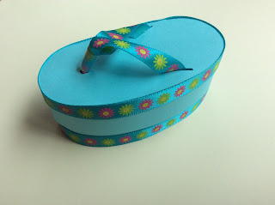

Summer Flip Flop Shoe Box

Summer is finally here! I designed a flip flop shoe box to hold some summer treats. It is a small box that can hold a few pieces of candy. It can hold 6 or 7 Hershey Kisses or 2 Lindt Chocolates. I made these boxes as presents for my co-workers at school. I will miss them as I decided to retire from teaching. However, I will have more time to make paper creations and blog about them...Yay!

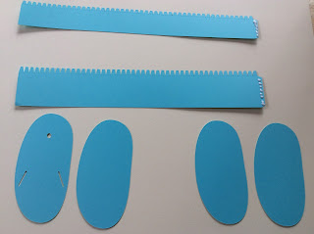

Put glue on the tabs as shown.

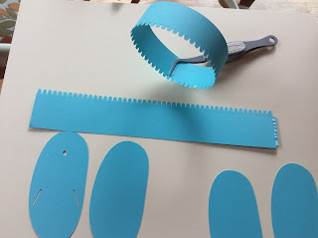

Make a circle. The tab should be on the inside of circle. This shorter height circle is the top of the box.

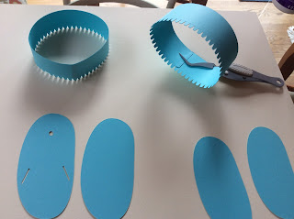

This taller height is the bottom of the box.

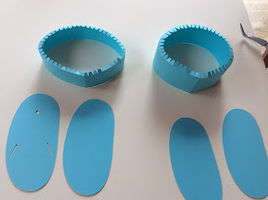

Fold the tabs on each of the circle as shown to make a ledge.

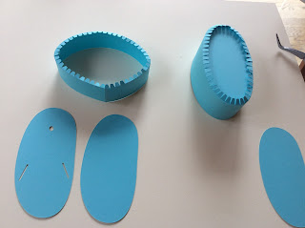

Place the smaller sole into the bottom of the box. This is the circle with the taller height. I like to put the seams halfway between the ends of the sole.

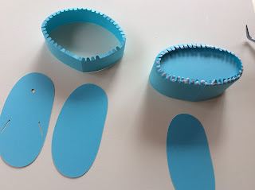

Put glue on each of the tabs as shown.

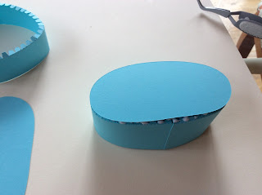

Attach the same size smaller sole.

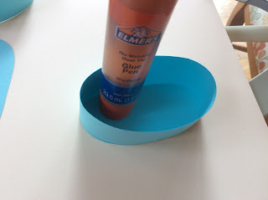

Apply pressure to make sure the bottom is glued tightly. I used a glue stick to apply pressure.

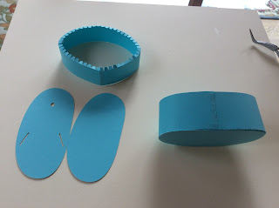

The bottom is complete.

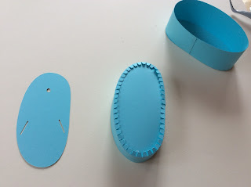

Place the sole in the lid as shown.

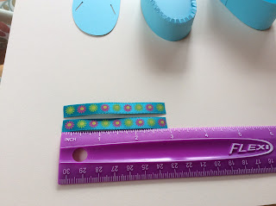

Cut two 3 inch pieces of ribbon. Cut a 3/8 inch piece of a drinking straw.

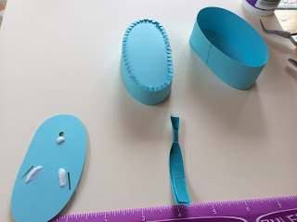

Slide the drinking straw onto the two pieces of ribbon. Place some glue on the sole as shown.

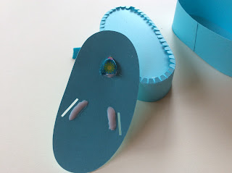

Thread the ribbon through the center hole.

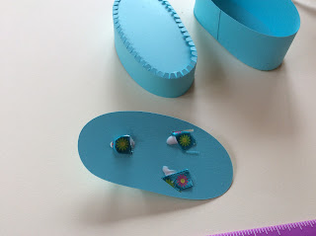

Thread each ribbon to the sides. Apply glue to each of the tabs as you did before.

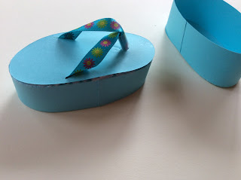

Attach the top of the flip flop.

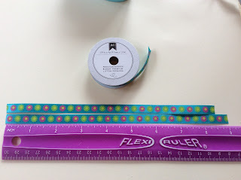

Cut two lengths of ribbon. One length is 8 1/2 inches and the other is 9 inches long.

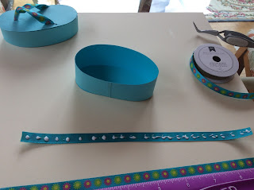

Apply glue to the back of the ribbon. The shorter length...8 1/2 inches is for the bottom of the box.

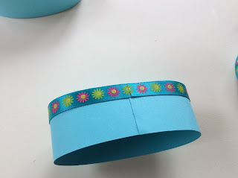

I started and ended the ribbon on the seam so all the seams are aligned.

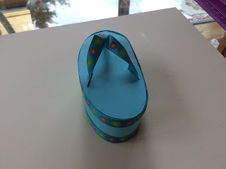

Glue the longer length of the ribbon to the top of the box.

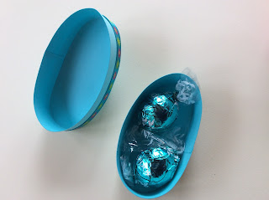

Here is the box with Lindt chocolate inside.

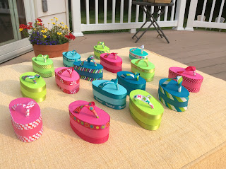

My Summer Flip Flop Boxes.

Enjoy! Happy Summer!